Problem 1

Write a C program that will take a character as input and convert it into uppercase if it is given as lowercase and vice-versa.

Source Code
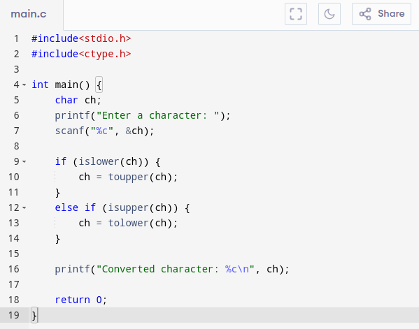

Input & Output

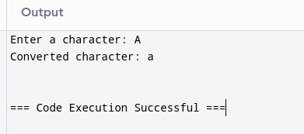
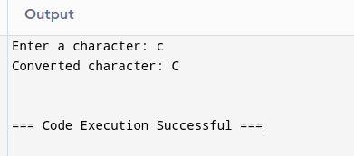
Problem 2

Write a C program to perform various formatted input/output operations on floating point numbers.

Source Code Input & Output
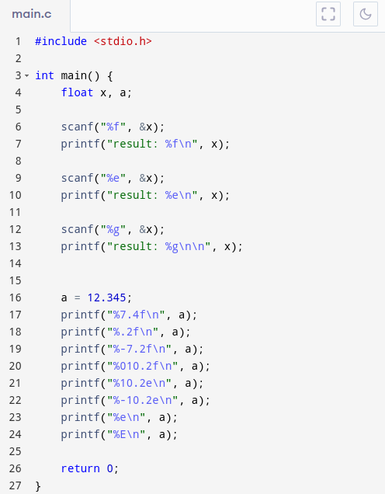
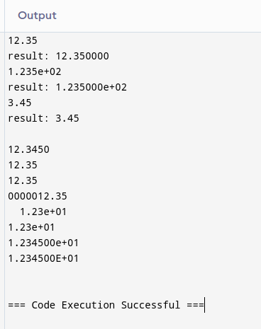

Problem 3

Write a C program for converting days into years, months and days.

Source Code

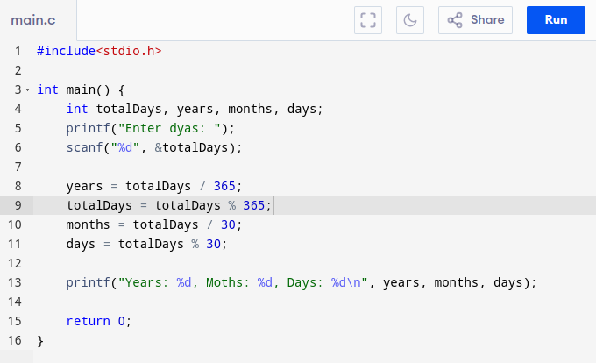

Input & Output

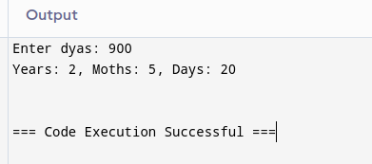
Problem 4

Write a C program for assigning (1 > 4 || 3 ! = 5) to a variable and print its value.

Source Code
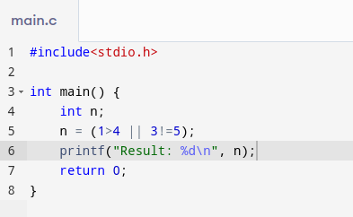

Input & Output

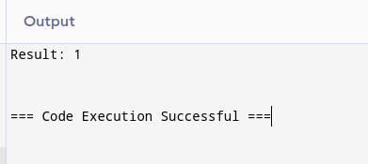
Problem 5

Write a C program to check whether a number is even or odd using bitwise operator.

Source Code
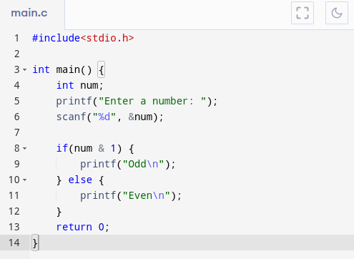

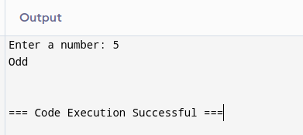
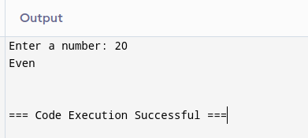
Input & Output

